# Student’s Enrollment System Design Document

## Entity Relationship diagram

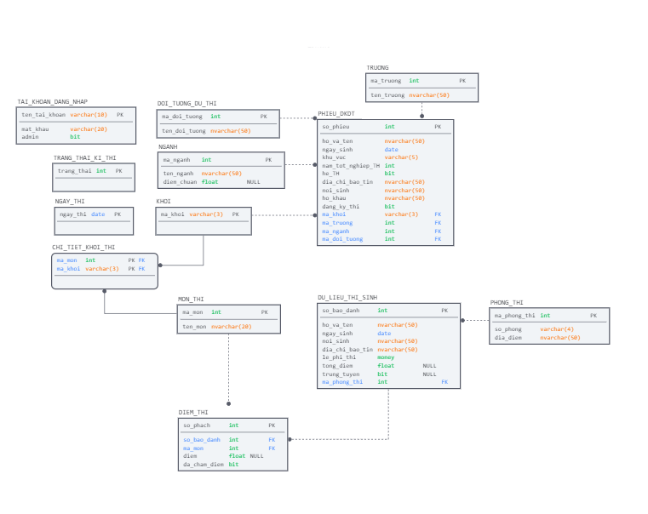

1.1 ERD

1.2 Database Diagram

## Class Diagram (visual studio)

1.2 Class Diagram

## Sequence Diagram

#### 1.3.1 Login

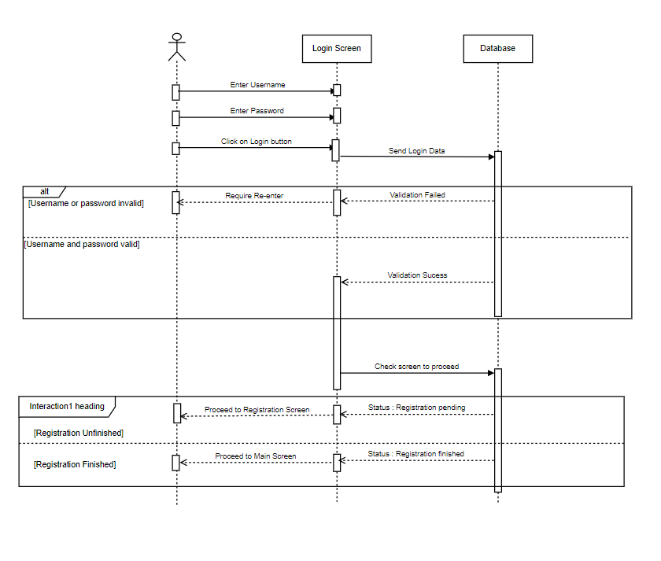

1.3.1 Login Sequence diagram

#### 1.3.2 Register a Candidate

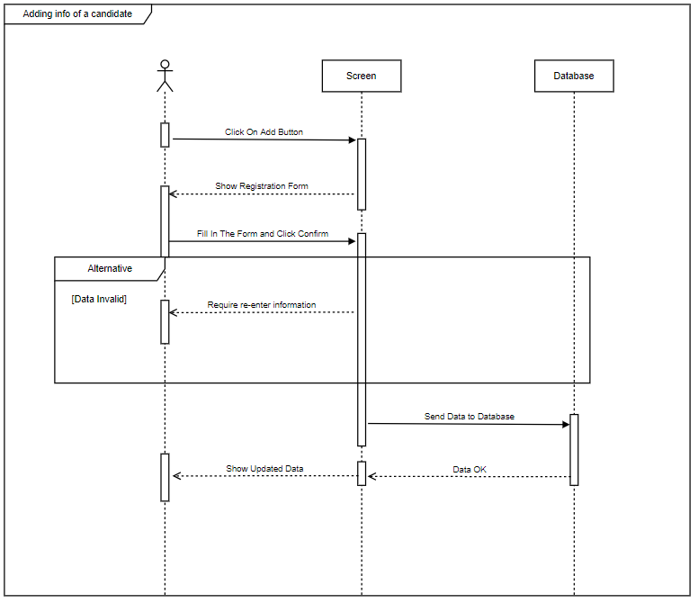

1.3.2 Register Sequence diagram

#### 1.3.3 Edit an existing Candidate in Registration Screen

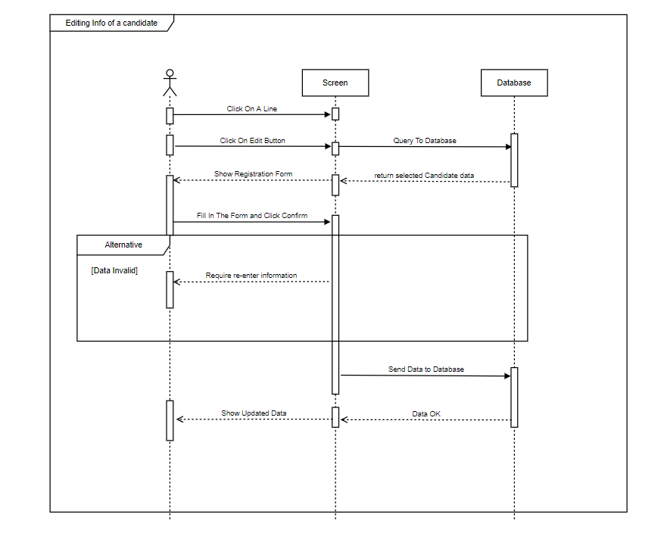

1.3.3 Edit Sequence diagram

#### 1.3.4 Finish Candidate Registration

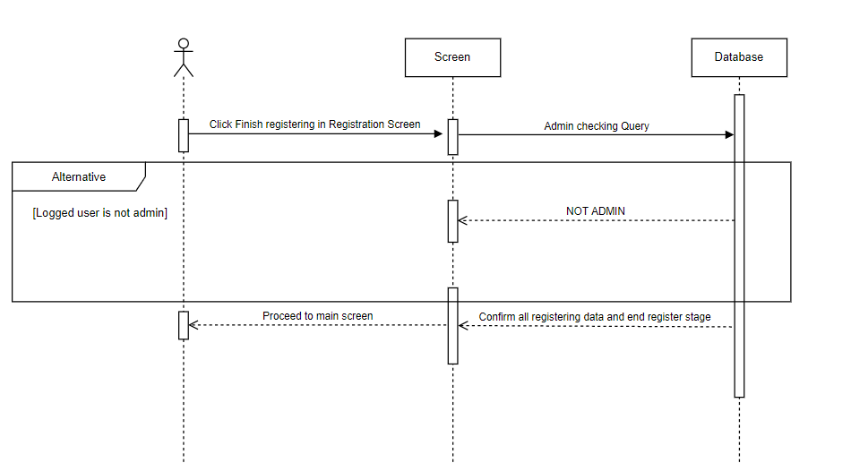

1.3.4 Finish Register phase Sequence diagram

#### 1.3.6 Edit Scores

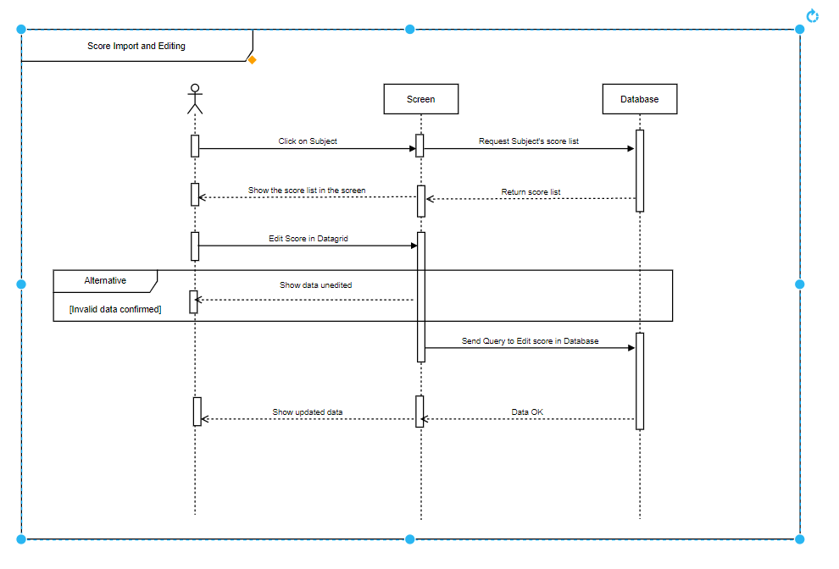

1.3.5 Edit Scores Sequence diagram

#### 1.3.7 Export Candidates Data

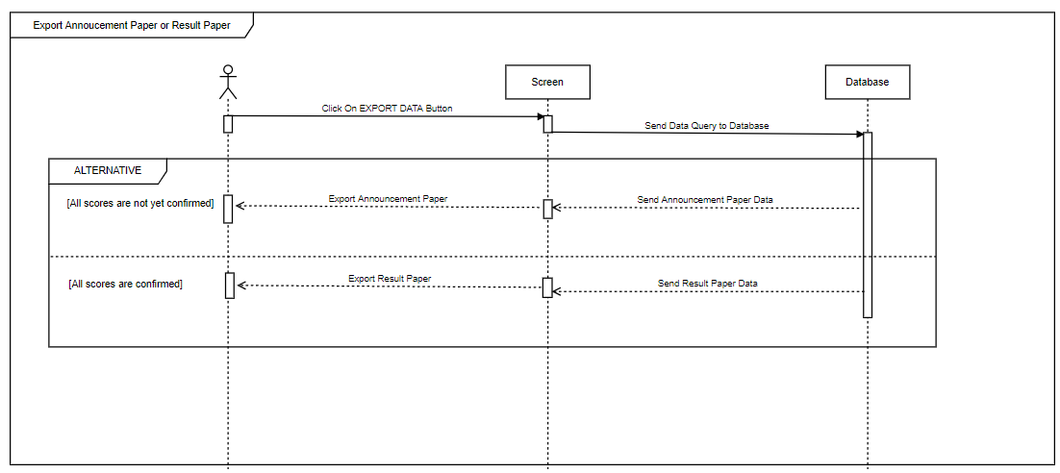

1.3.6 Export Sequence diagram

#### 1.2.8 Show Statistics

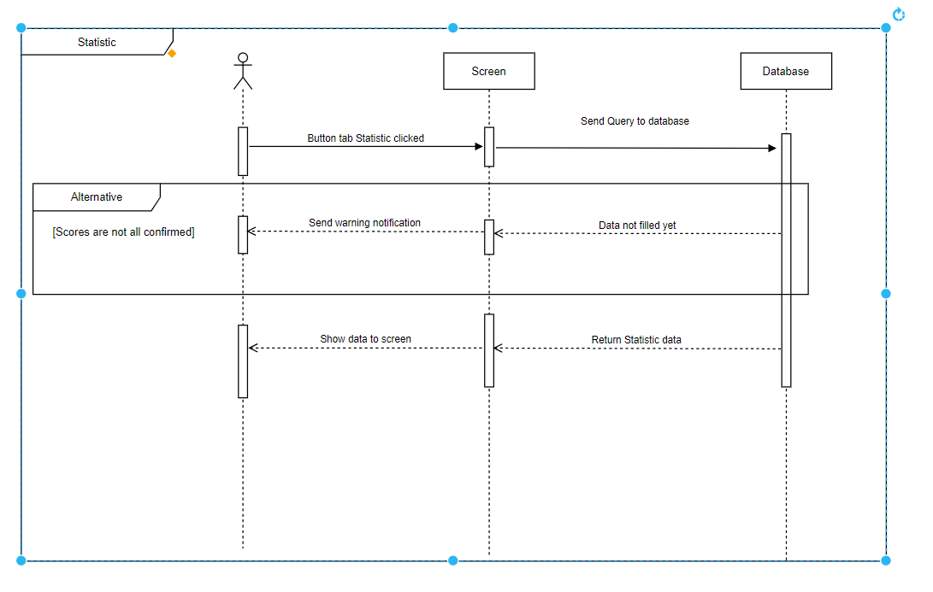

1.3.7 Show Statistic Sequence diagram

## Screen Flow Diagram

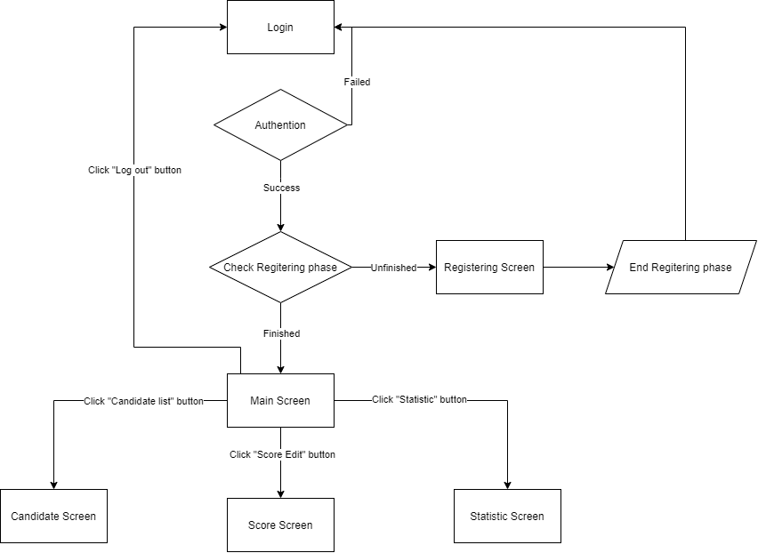

## Screen Detail

### 1.4.1 Login Screen

##### 1.4.1.1 Main Flow

|  |  |
| --- | --- |
| Screen | Screen for login |
| Description | Login |
| Screen Access | On Application Opening On clicking Log out button |

##### 1.4.1.2 UI

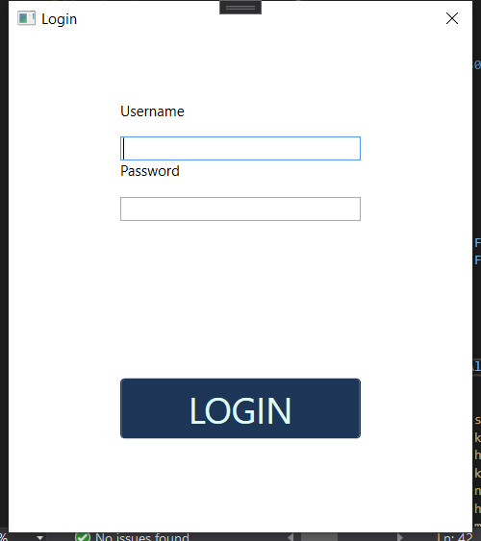

##### 1.4.1.3 Data Mapping / Validation Rule

|  |  |  |
| --- | --- | --- |
| **Field** | **Type** | **Description** |
| Username | Textbox | Input Username |
| Password | PasswordBox | Input Password |
| Login | Button | Click to Login into system  Use dbo.System_Login to check whether account is valid. |

### 1.4.2 Candidate Register Information Screen

##### 1.4.2.1 Main Flow

|  |  |
| --- | --- |
| Screen | Candidate Register Information Screen |
| Description | Screen contain data of candidate registration |
| Screen Access | On Login before registration stage finished |

##### 1.4.2.2 UI

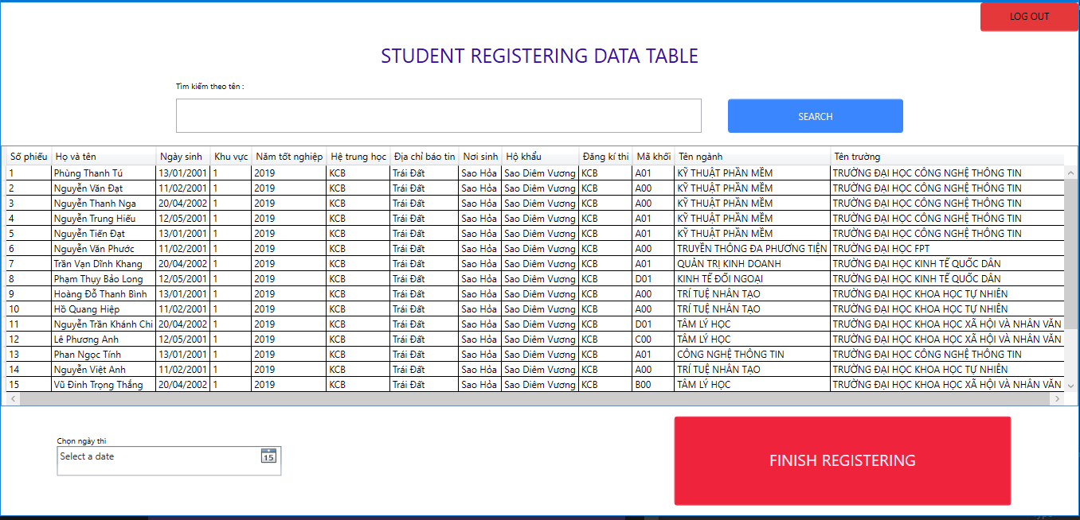

##### 1.4.2.3 Data Mapping / Validation Rule

|  |  |  |
| --- | --- | --- |
| **Field** | **Type** | **Description** |
| Candidate Registration Information Grid view | DataGridview | Contains Data of Candidate Registration  Use dbo.PHIEU_DKDT.  Cannot be edited directly. |
| Search bar | Textbox | Search by name |
| Search | Button | Click to search |
| Log out | Button | Click to logout |
| FINISH REGISTERING | Button | Confirm candidate registration data to end Registration Stage ( only admin can use this button) |

### 1.4.3 Candidate List

##### 1.4.3.1 Main Flow

|  |  |
| --- | --- |
| Screen | Candidate List Screen |
| Description | Contain Information of Attended Candidate |
| Screen Access | On Login After Registration Stage Finished |

##### 1.4.3.2 UI

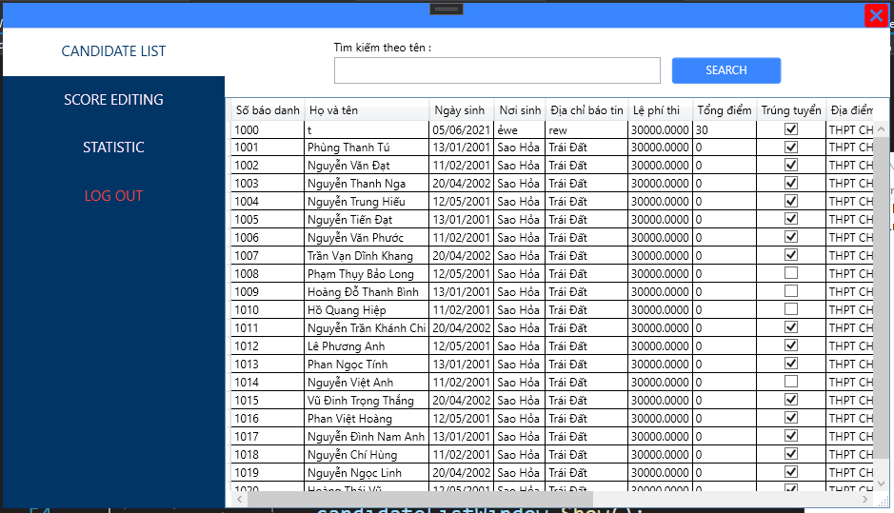

##### 1.4.3.3 Data Mapping / Validation Rule

|  |  |  |
| --- | --- | --- |
| **Field** | **Type** | **Description** |
| CANDIDATE | Button | Refresh the screen to get data updated |
| SCORING | Button | Change to Scoring screen |
| STATISTIC | Button | Change to Statistic Screen if Scoring finished |
| Log out | Button | Return to login screen |
| Data Grid view | DataGridview | Contains uneditable data of candidate  Using dbo.THI_SINH,dbo.GIAY_BAO_THI  Dbo.KET_QUA_THI  Dbo.KET_QUA_TUYEN_SINH |
| Search bar | Textbox | Search by name |
| Search button | Button | Filter Searches |

### 1.4.4 Scoring screen

##### 1.4.4.1 Main Flow

|  |  |
| --- | --- |
| Screen | Scoring screen |
| Description | Screen for selecting subjects to open score list |
| Screen Access | On clicking “Scoring” button |

##### 1.4.4.2 UI

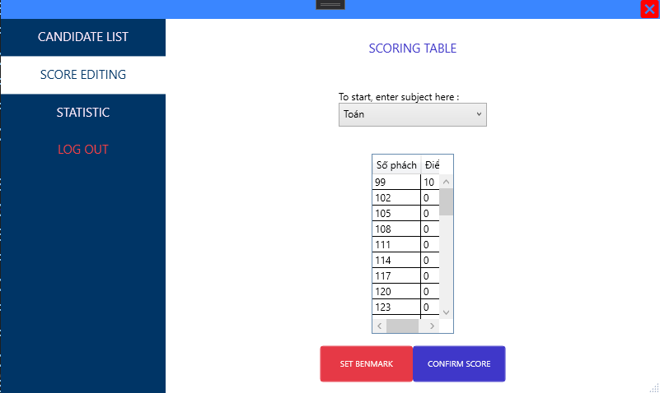

##### 1.4.5.3 Data Mapping / Validation Rule

|  |  |  |
| --- | --- | --- |
| **Field** | **Type** | **Description** |
| CANDIDATE | Button | Move to Candidate List screen |
| SCORING EDIT | Button | Return to Scoring Screen |
| STATISTIC | Button | Move to Statistic Screen if Scoring state finished |
| Log Out | Button | Return to login screen |
| Confirm Score | Button | Confirm subject score, if all subject confirmed, the scoring stage will be finished. |
| Set Benchmark | Button | Set major benchmark |
| Score DataGrid | DataGridview | Use dbo.KET_QUA_THI  Show editable score of candidate. |

### 1.4.6 Statistic Screen

##### 1.4.6.1 Main Flow

|  |  |
| --- | --- |
| Screen | Statistic screen |
| Description | Show some Statistic of the enrollment |
| Screen Access | On Click STATISTIC button after scoring state finished |

##### 1.4.6.2 UI

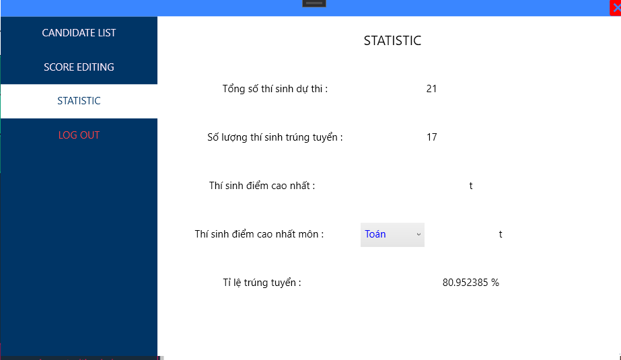

##### 1.4.6.3 Data Mapping / Validation Rule

|  |  |  |
| --- | --- | --- |
| **Field** | **Type** | **Description** |
| CANDIDATE | Button | Move to candidate screen |
| SCORE EDITING | Button | Move to scoring screen |
| STATISTIC | Button | Refresh the screen |
| Log out | Button | Return to login screen |
| STATISTIC BOARD | Grid | Show statistic of the enrolment exam |
| Subject-choosing combo box | Combobox | Change the subject to show the best candidate on that subject |

### 1.4.7 Registration Information Editing Screen

##### 1.4.7.1 Main Flow

|  |  |
| --- | --- |
| Screen | Registration Information Editing Screen |
| Description | Screen to edit candidate registration data line or add new |
| Screen Access | On click edit or add button at the candidate registration screen |

##### 1.4.7.2 UI

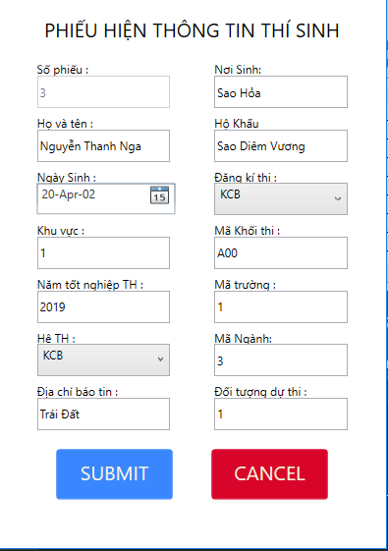

##### 1.4.7.3 Data Mapping / Validation Rule

|  |  |  |
| --- | --- | --- |
| **Field** | **Type** | **Description** |
| numID | Textbox | “Số phiếu” use dbo.PHIEU_DKDT  Column so_phieu  Uneditable |
| Subject Stack | Combobox | “Khối thi” use dbo.PHIEU_DKDT  Column khoi_thi |
| Name | Textbox | “Họ và tên” use dbo.PHIEU_DKDT  Column ho_va_ten |
| Type of Education | Textbox | “Hệ đào tạo”  Use dbo.PHIEU_DKDT  Column he_dao_tao |
| Graduate Year | Textbox | “Năm tốt nghiệp” Use dbo.PHIEU_DKDT  Column nam_tot_nghiep  Data must be 4 digit number |
| Area type | Combobox | “Khu vực” Use dbo.PHIEU_DKDT  Column khu_vuc |
| Enrolment Type | Combobox | “Đăng kí thi”  Use dbo.PHIEU_DKDT  Column dang_ki_thi |
| College ID | Textbox | “Mã trường” Use dbo.PHIEU_DKDT Column ma_truong  Data must in the list listed on the dbo.TRUONG |
| Speciality ID | Combobox | “Mã ngành” Use dbo.PHIEU_DKDT  Column ma_nganh  Data must be listed in dbo.NGANH |
| DoB | Textbox | “Ngày sinh” Use dbo.PHIEU_DKDT Column ngay_sinh  Data must formatted date |
| PoB | Textbox | “Nơi sinh” Use dbo.PHIEU_DKDT  Column noi_sinh |
| Announce Address | Textbox | Use dbo.PHIEU_DKDT  Colum dia_chi_bao_tin |
| SUBMIT | Button | Confirm data and update to database (If data valid) |
| CANCEL | Button | Close the form |